LAB 10

Task 1:

Output:

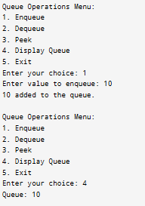

Task 2:

Output:

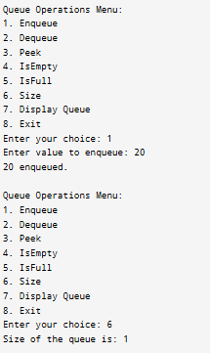

Task 3:

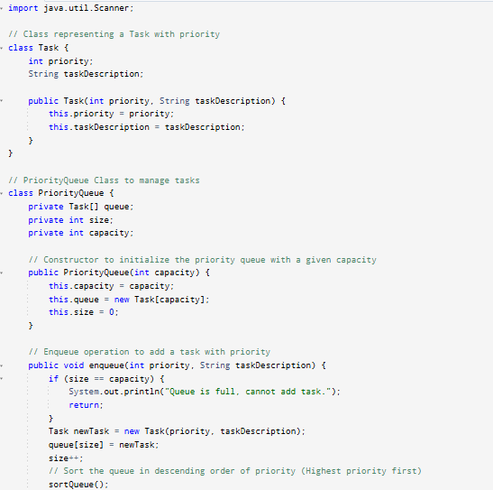

Output:

